

**Tribhuvan University**

**Faculty of Humanities and Social Sciences**

**A PROJECT REPORT ON**

**Ecommerce Website**

**Submitted to**

Department of Computer Application

Bajra International College

**In partial fulfilment of the requirements for the Bachelors in Computer Application**

**Submitted by**

Name: Milan Karki

Roll No: - 05

Tu Register No: 6-2-712-52-2019

09-03-2079

**Under the Supervision of**

**Niresh Dhakal**



# Tribhuvan University

# Faculty of Humanities and Social Sciences

# Bajra International College

**SUPERVISOR’S RECOMENDATION**

I hereby recommend that this project prepared under my supervision by MILAN KARKI entitled “E COMMERCE WEBSITE” in partial fulfilment of the requirements for the degree of Bachelor of Computer Application is recommended for the final evaluation.

Signature of the Supervisor



**Tribhuvan University**

**Faculty of Humanities and Social Sciences**

**Bajra International college**

# LETTER OF APPROVAL

This is to certify that this project prepared by MILAN KARKI entitled “E COMMERCE WEBSITE” in partial fulfilment of the requirements for the degree of Bachelor in Computer Application has been evaluated. In our opinion it is satisfactory in the scope and quality as a project for the required degree.

|  |  |
| --- | --- |
| ……………………………………  Mr. Niresh Dhakal  Boudha-6, Jorpati  BAJRA INT College | …………………………………………  Mr.  Chief Academic Officer  BAJRA INT College |
| …………………………………………..  External Examiner  Academic designation  Tribhuvan University | …………………………………………..  Mr. Anzal Sharma  Boudha-6, Jorpati  BAJRA INT College |

**Bajra International College**

Ref No:

Date: 2079-03-09

Subject: Approval of Project Proposal

The project entitled “E Commerce Website” proposed by Mr. Milan Karki for the partial fulfilment of the requirement for Bachelor in Computer Application (BCA), fourth semester has been approved for further development.

Proposal Evaluation Committee

1. _______________________

2. _______________________

3. _______________________

4. _______________________

_______________________

Mr. Madhu Sudhan

Boudha-6, Jorpati

BAJRA INT College

Campus Chief (.)

# ACKNOWLEDGEMENT

This project has been prepared for the partial fulfillment of the requirement for BCA Fourth Semester PROJECT I course designed by TU.

Knowledge is not just limited on our books and our words; it varies on our experience, on the way facing the time and situation that passes across us. The project work on E COMMERCE WEBISTE is an excellent way to collaborate the knowledge in our mental attitudes in an IT sector.

The project is a successful work, and this project is a perfect symbolization of knowledge, friends and teacher. First of all, I would like to thank my parents who help me a lot by providing suitable environment more or less, accessories and economical support required for the project. Again, I would like to express my gratitude and appreciation to all who contributed directly or indirectly while preparing this project.

In this project Supervised by Supervisor Mr. Niresh Dhakal of Bajra International College I have investigated and applied the use of ECOMMERCE. The main aim of making this project is to know about CRUD OPERATION and its function. By doing this project I was able to understand about different uses and application of software and present it as example through my project.

Really, this project is an excellent example of co-ordinate and united team as well as other helpful faces and hands.

Thank You!!!

Tu Register No: 6-2-712-52-2019

Name: Milan Karki

Semester: BCA Fourth Sem

Level: Bachelors in Computer Applications

# ABSTRACT

The business to consumer aspect of electronic commerce (e-commerce) is the most visible business use of the Word Wide Web. The primary goal of an e-commerce site is to sell goods and services online. This project is a web-based shopping system for an existing shop. The project objective is to deliver the online shopping application. This project is an attempt to provide the advantages of online shopping to customers of a real shop. It helps buying the products in the shop anywhere through internet by using a web site. Thus, the customer will get the service of online shopping and home delivery from this shop. This system can be implemented to Sai Supermarket in the locality. If shops are providing an online portal where their customers can enjoy easy shopping from anywhere, the shops won’t be losing any more customers to the trending online shops such as Hamro Bazar, Daraz, Pathou Food. Since the application is available in the given site it is easily accessible and always available.

TABLE OF CONTENT

SUPERVISOR’S RECOMENDATION

LETTER OF APPROVAL

# ACKNOWLEDGEMENT

# ABSTRACT

CHAPTER 1: INTRODUCTION 1

1.1 Introduction 1

1.2 Problem Statement 2

1.3 Objective 2

1.4 Scope and Limitations 2

1.4.1 Scope 2

1.4.2 Limitations 2

1.5. Report Organization 3

CHAPTER 2: BACKGROUND STUDY AND LITERATURE REVIEW 4

2.1 Background Study 4

2.2 Literature Review 4

CHAPTER 3: SYSTEM ANALYSIS AND DESIGN 7

3.1 System Analysis 7

3.2 Requirements 9

3.2.1 Functional requirement. 9

3.2.3 Non-Functional Requirement 11

3.4 Feasibility study: 11

3.4.1 Technical feasibility 11

3.4.2 Economic feasibility 12

3.4.3 Operational feasibility 12

3.4.4 Schedule Feasibility 12

3.5 Entity Relationship Diagram (ERD) 13

3.6 Process Modelling (DFD) 14

3.6.1 Data Flow Diagram Level 0 14

3.6.2 Data Flow Diagram Level 1 15

3.6.3 Data Flow Diagram Level 2 16

CHAPTER 4: IMPLEMENTATION AND TESTING 17

4.1. Implementation 17

4.1.1. Tools Used 17

4.1.2. Implementation Details of Modules 19

4.2 Testing 20

4.2.2. Test Case for System Testing 21

Register page test case 21

Login page Test case 21

Shopping cart Test case 22

CHAPTER5: CONCLUSION AND FUTURE RECOMMENDATION 23

5.1. Outcome 23

5.2. Conclusion 23

5.3. Future Recommendation 24

REFERENCES 25

APPENDICES

**LIST OF FIGURES**

Fig 3.1: Waterfall model  8

Fig 3.2.2: Use case diagram of Ecommerce website  10

Fig 3.4.4: Gantt Chart of Ecommerce website 12

Fig 3.5: Entity Relationship Diagram for Ecommerce website 13

Fig 3.6.1 Data Flow Diagram Level 0 14

Fig3.6.2 Data Flow Diagram Level 1 15

Fig 3.6.3 Data Flow Diagram Level 2 16

LIST OF TABLES

Table 1: Register page test case 21

Table 2: Login page Test case 21

Table 3: Shopping cart Test case 22

# CHAPTER 1: INTRODUCTION

## **1.1 Introduction**

E-commerce (electronic commerce) is the buying and selling of goods and services, or the transmitting of funds or data, over an electronic network, primarily the internet. These business transactions occur either as business-to-business (B2B), business-to-consumer(B2C), consumer-to-consumer or consumer-to-business [1].

Nepal is a developing country and Information Communication and technology are playing their important roles in development of the country. By ecommerce we mean Buying and selling of products or services over electronic systems such as the Internet and other computer networks. In truth in Nepal, we have very less ways to pay our bills online or trade online. But that does not mean we cannot. There are new players on Nepali ground like Daraz, Hamro Bazar, Khalti, E-sewa etc who wants to revolutionize the way Nepali ecommerce field is taken. With launch of these services many new start-ups can easily sell their products and services online. These services have lots of potential and we hope it will succeed and bring a change in the Nepali ecommerce field. There are big and old player like muncha.com in Nepal which is already popular for its money transfer and online shops.

E-commerce is fast gaining ground as an accepted and used business paradigm. More and more business houses are implementing web sites providing functionality for performing commercial transactions over the web. It is reasonable to say that the process of shopping on the web is becoming commonplace.

The objective of this project is to develop a general-purpose e-commerce store where any product can be bought from the comfort of home through the Internet.

An online store is a virtual store on the Internet where customers can browse the catalog and select products of interest. The selected items may be collected in a shopping cart. At checkout time, the items in the shopping cart will be presented as an order. At that time, more information will be needed to complete the transaction.

Usually, the customer will be asked to fill or select a billing address, a shipping address, a shipping option, and payment information. An e- mail notification is sent to the customer as soon as the order is placed.

## **1.2 Problem Statement**

In context of Nepal many organizations/ businesses are still doing physical shopping business and they are trying and wanted to shift online so that they can provide their services. So, this project will help them to provide these services online.

## **1.3 Objective**

1.To make Ecommerce website which will help the organization to operate them in business-to-consumer(B2C) model.

## **1.4 Scope and Limitations**

## **1.4.1 Scope**

1. Any (Authorized, Guest) user can use this system.
2. Admin can easily manage the whole system.

## **1.4.2 Limitations**

1. Payment, Watchlist, and review system is not included in this project.
2. This system is currently limited to few categories only.
3. Advance shopping cart and inventory system for stock calculation is currently missing.

## **1.5. Report Organization**

This report document contains five chapters including this chapter. Chapter two defines and describes Background Study and Overview of related existing systems and their pros and cons. Chapter three presents the System Analysis and Design including Requirement Analysis and Feasibility Analysis. Chapter four presents the Implementation, Testing and debugging are explained. In chapter five, Conclusion on, Limitations and Future Enhancement are briefly explained.

# CHAPTER 2: BACKGROUND STUDY AND LITERATURE REVIEW

## **2.1 Background Study**

In today's world the use and access to the internet is so high so most of the people are busy on their own work so we have developed this module so that user can create and access to their account through the use of internet and general concept and terminologies are mentioned below.

* Create New Account: A user can create an account through registration process and user can create an account when there is access of internet through this module.
* Login: After creation of account user can login through their detail and can access to their e-commerce through this module
* Surfing: After successful login user can surf through different categories to buy whatever they need.
* Add to cart: After finding the desired items you can add them to cart and proceed to cash out,
* Payment: After adding items to cart, user can add or delete those items and proceed for the final payment.

## **2.2 Literature Review**

In a developing country like Nepal, e-commerce was initially started introduced in 1999, with the concept of shipping presents and gifts, allowing Nepalese travelling overseas, particularly in the United States, to give presents to friends, loved ones and relatives (Malla, 2018). E-commerce though is popular currently still is at the infancy stage currently in Nepal whether it being B2B or B2C e-Commerce. (International Trade Administration, 2019). E-commerce marketplace such as Daraz, Sastodeal, Nepbay, Hamrobazar are currently present in Nepal which act as an online marketplace for merchants to communicate and sell products. There are currently various online payment gateways available such as Khalti, E-Sewa which are mobile wallets, Ipay, Qpay, local bank payment used for making payments. But people should have dollar account to make payment to merchants in foreign currency (International Trade Administration, 2019). Mobile e-commerce is also growing popular now-a-days. Out of total population, 60% have internet access and 95% out of those population will access through mobile (International Trade Administration, 2019). As per MIS report from Nepal Telecommunications authority on March 2020, approximately there are 21,852,338 broadband users (Nepal Telecommunication Authority, 2020). And as of March2021, there are approximately 26,256,005 broadband users (Nepal TeleCommunications Authority, 2021). This shows increasing number of broadband users and people going online that results in more potential online consumers. At present, people are moving to online business from traditional approach (Rani, and Kautish, 2018, 2019). Also, there is increase in number of people purchasing online from ecommerce providers such as online marketplace. We can take example of Daraz Nepal, established in 2016. It is considered the most popular e-commerce marketplace currently in Nepal. Daraz Nepal has been able to provide its services through website and mobile application. It supports payments though Debit/Credit cards, and E-Sewa (a mobile wallet for making online payment). As per study conducted by (Crofts & Pokhrel, 2018), in their research paper they concluded that ecommerce business is a growing platform and has potential but has some challenges such as security, payment gateways, transportation, manpower (Crofts & Pokhrel, 2018). As per study conducted by author Chiranjivi on ecommerce online marketplace Daraz Nepal, the author concluded that quality service and product is a challenge (Pathak, 2020). Another popular online marketplace includes Sastodeal, established in 2011 with an objective to start e-commerce industry and currently provides delivery to most parts of Nepal with an affordable price point (SastoDeal, 2021). The company had recently joined forces with Flipkart an Indian e-commerce company where Flipkart will sell products through Sastodeal in Nepal. People are adapting to new ways and technologies to conduct business. People currently are choosing to move their businesses online to extend their customer base. We observed various ecommerce marketplace in Nepal such as Daraz, HamroBazar, SastoDeal, Muncha house, Foodmandu and some e-commerce online store such as Evo store, Olizstore dedicated to promote their brand. We also observed currently some e-commerce platform providers are not yet popular in Nepal such as Shopify, Magento, WooCommerce. With the help of these platforms, merchants will be able to have their own e-commerce websites and customize them as per requirements. Limited amount of e-commerce platforms can be observed which may be due to challenges such as trust issues, online payments, security, internet connection unavailability, government policies and some others.

Technology is covered almost all across the world. There are various available models for describing the technology acceptance. One of them is Technology acceptance model, a tool used for assessing new technology acceptance based on user perceptions. According to Technology acceptance model, that explains two factors for accepting of computer system by its intended users, the first is perceived usefulness and second is perceived ease of use (Davis, 1989). When a technology is invented the inventor believes that it is useful and user-friendly, but the potential consumers may not embrace it. As per authors (Legris, Ingham, & Collerette, 2003) in their study mentioned the outcomes of empirical studies employing TAM are not completely consistent or clear. There are also few other models and some of them include TAM2 model, Theory of reasoned action (TRA), Theory of planned behavior (TPB), UTAUT models. With various models for technology acceptance, authors used it to describe the technology acceptance. As per author Tong (2010), had findings that customer online purchase intentions are invariant to perceived usefulness and perceived risk of purchasing online, but not previous online shopping experience (Tong, 2010). Authors Fayad and Paper (2015) in their research argued that in current form TAM will not adequately explain behavior of online consumer because e-commerce adoption differs significantly from organizational adaption of new technologies (Fayad & Paper, 2015). According to authors (Awa & Ukoha, 2015) in their study mentioned, Technology Acceptance model, Theory of planned behavior and Technology organization environment presents valuable insight as to how business adopt to e-commerce but improvement on these model as done by authors in their study gives SME’s more flexibility to maintain and improve advantage over competitors. Various researchers have used the model in their paper to analyze the technology acceptance and results showed these models helped for technology acceptance even though the model have been called not being useful in certain cases. Similarly, we can apply the model for acceptance of ecommerce platform technology by people [3].

# 

# CHAPTER 3: SYSTEM ANALYSIS AND DESIGN

## **3.1 System Analysis**

Considering the fact that this project involves design and implementation of a software system regardless that is web-based, it will be important to mention and consider some models used in software development and deployment, some general models of software development are namely:

**The waterfall model** fits the development of this website. The main aim of using this approach is we can focus on each part of the model during development and come back to it if need be. The project can easily de broken down into different parts based on this model.

This is the model that will be used to develop the E-Commerce system. However, feedback loops will be allowed during the whole software development process. The model chosen for this project has to favours two developers for a project. Because we are the only ones who are going to implement this project. We find this model suitable for us to follow.

It requires that software development follows the following stages:

* Requirements are to be proposed.
* System design should be made according to the requirements.
* Implementation of the features according to the design.
* Integration and testing of the system.
* Deployment of the system.
* Maintenance of the system.

Waterfall methodology is used while building this website. This project has specific documentation, fixed time, fixed requirements, well-understanding technology so in order to build this system waterfall methodology can be properly utilized.

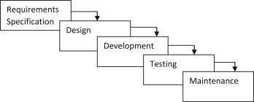

***Fig 3.1: Waterfall model***

## 

## 

## **3.2 Requirements**

Requirement analysis is done so that the project gets the necessary features and will be easy for analysing system. It is a key instrument used to determine the needs and expectations of a new product. In this project requirements are categorized into two parts i.e. functional requirements and non-functional requirements.

For any system, there are functional and non-functional requirements to be considered while determining the requirements of the System.

**3.2.1 Functional requirement:** In this project the functional requirements are categorized into two different models i.e., User Module and Admin Module. Under User Model user can easily use the features like registration, login, viewing products, and adding products to cart. Whereas Admin Module consists of using the system as an administrative which consists of features like managing products, managing users and viewing orders. The Functional requirements in the project are mentioned below.

**User Module:**

* User shall register and login the system.
* Users shall look at their cart detail.
* User shall get cart detail after updating each product.

**Admin Module:**

* Admin shall login the system.
* Admin shall Insert, Update, and Delete products.
* Admin shall see the registered users.
* Admin shall delete the user.
* Admin shall view order from the user.

**3.2.2 Use Case Diagram**

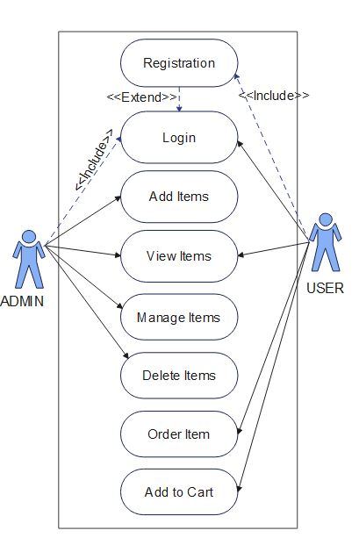A use case diagram is used in this project which will help to understand the dynamics of a system, we need to use different types of diagrams. Use case diagram is one of them and its specific purpose is to gather system requirements and actors a graphic depiction of interactions among different elements in a system. From the diagram we can clearly see the two actors i.e. Admin and user. The rectangle box is the system boundary and the Include is the necessary and must be required in order to get access to the system. And the Extend is the add on and will redirect the system. The main function used by Admin actor is that it must login into the system and after login admin will be able to add items, view items, manage items, and be able to delete items. On the other side User actor will must first register into system and then he will be redirected to login page and user will be able to view items, order items and be able to use add to cart feature.

***Fig 3.2.2: Use case diagram of Ecommerce website***

**3.2.3 Non-Functional Requirement**: The non-functional requirement is used so that it will specifies how the system works. Non-functional requirements act as an add on feature in this project. The non-functional requirements included in the project are:

* Availability: It must be available 24/7 online
* Security: This system must be secure and the user’s information won’t be available for others for users’ privacy.
* Performance: This system must be designed for smooth performance with optimization and good response.

**3.4 Feasibility study**: A feasibility study is an evaluation and analysis of a project or system that somebody has proposed. Following feasibilities were studied before building the system to see if the system could be built with exact requirements in required time.

**3.4.1 Technical feasibility:** In order to design this system, it uses existing technologies, software and hardware so there is no technological hurdle to build this system.

* The UI of our project is very simple
* User will require internet browser and internet to use it
* It will run on many existing web browsers with the latest versions and even in the smart phones.

**Tools and Technology Used:**

The Following software is used for the development of the System.

* VS Code
* MySQL
* Apache [Xampp]
* Minimum Windows 8 required.

**3.4.2 Economic feasibility:** Before the development of a system, the proposed system should be studied whether or not it is within the budget estimated by the organization. The project that we are developing is within the cost estimation of the organization. The project cost is less and no more burdens are needed. The system development does not have any requirement of expensive hardware and software. The platform are open sources and the resources required for the project are also open source. Hence the project is said to be economically feasibility

**3.4.3 Operational feasibility:** These include the reliability, maintainability, usability, supportability. The proposed system is operationally feasible as it is reliable for all type of user i.e., whether or not the user has the knowledge of computer or not. The proposed system is supported for a small to large-scale organization. It is simple and easy to use due to simple user interface and its operational feasible.

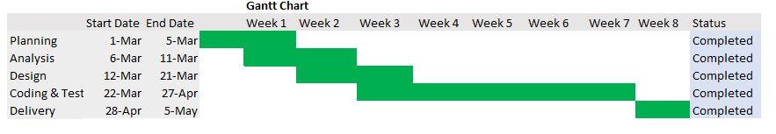**3.4.4 Schedule Feasibility**: The system that we developed is scheduling feasible as it does not require more time for the development phase. The data collection takes more time to collect the data about various products and their quality. After data is collected, the other development phase can be within a month. Gantt charts: Gantt chart is a bar chart that provides a visual view of tasks scheduled over time. A Gantt chart is used for planning projects of all sizes, and it is a useful way of showing what work is scheduled to be done on a specific day- It can also help you view the start and end dates of a project in one simple chart. In our project, we used Ms. Excel for developing the Gantt chart which is shown below in the figure.

## 

***Fig 3.4.4: Gantt Chart of Ecommerce website***

## **3.5 Entity Relationship Diagram (ERD)**

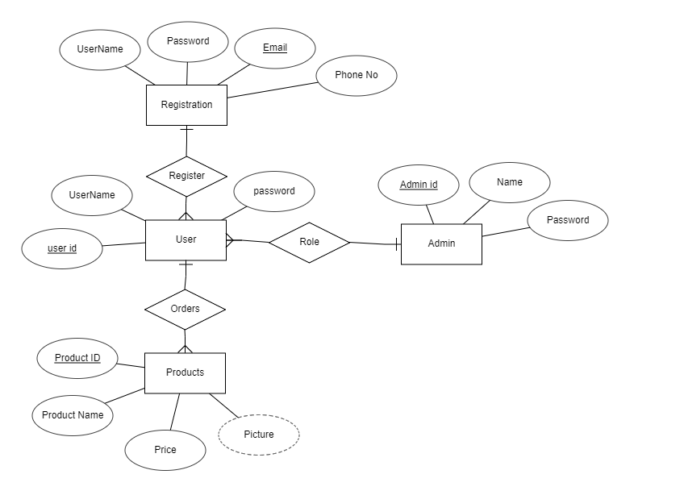Entity Relationship Diagram (ERD) is used in this project as it helps to analyse in the database and helps us to produce a well-designed database. It is considering a best practice to complete ERD before implementing database. From the figure we can see that the diagram is categorized in four types of entity set i.e., Registration, User, Admin, Products. And Registration has four types of attributes i.e. Username, Password, Email, Phone no in which Email is primary key and Registration have one to many Relationship with User. User have three attributes i.e., User id, Username, and Password in which User id is primary key. User have many to one relationship with Admin. Admin have three attributes i.e., Admin id, Name, and Password in which Admin id is primary key. Admin have privilege to manage user. User also have one to many Relationship with Products. Products have four attributes i.e. Product id, Product name, Price, and Picture in which Product id is primary key and Picture is derived attribute as it various on different products.

***Fig 3.5: Entity Relationship Diagram for Ecommerce websit******e***

## **3.6 Process Modelling (DFD)**

Data Flow Diagram (DFD) is used in this project as it helps to represents the information flow for any process or system. It shows data inputs, outputs, storage points, and the routes between each destination using defined symbols such as rectangles, circles, and arrows, as well as short text labels. DFD are classified into three model i.e., level 0, level 1, and level 2. Each update in level consists of expanding the model.

## **3.6.1 Data Flow Diagram Level 0**

The Level 0 DFD Diagram for E-commerce Website contains the basic yet general process of the system. Its purpose is to give the system analyst and programmers the basis for further process. The reason why the DFD Level were done one-by-one is to see and avoid flaws while still designing the diagram.

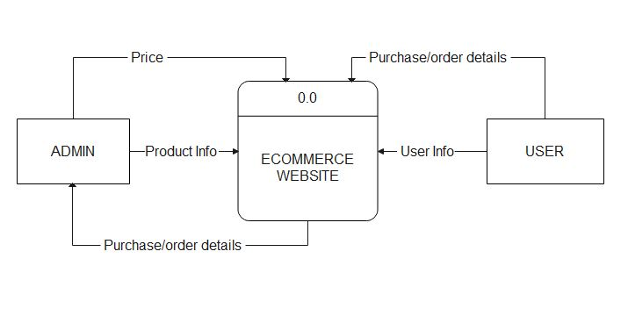DFD Level 0 presents the main idea to be the basis for the proceeding levels. The basic idea is represented by a single process consisting the main process, users and data. As we can see from the diagram the DFD Level 0 represents website, Admin, and User. Admin Send the Price and Product info to the website and receives Purchase details. Whereas Users send purchase.

## 

***Fig 3.6.1: DFD Diagram (level 0 DFD) for Ecommerce Website***

## **3.6.2 Data Flow Diagram Level 1**

The DFD Level 1 Diagram for E-commerce Website provides a broad overview and greater depth of DFD Level 0. The single process node from the context diagram is broken down into sub processes to see the included data that may enter and exits system.

DFD Level 1 lists all of the included processes that make up the entire system. It is the broadened context terms that consist of several processes derived from the main process. They were also numbers to see that were all part of the single process from E-Commerce Website DFD Level 0. As we can see from the diagram the DFD Level 1 represents Process 1.1 as Manage customer information and flow the data to Admin Entity and Receives data from user. Process 1.2 represents Manage product information and Receives data from both Admin and User entity.

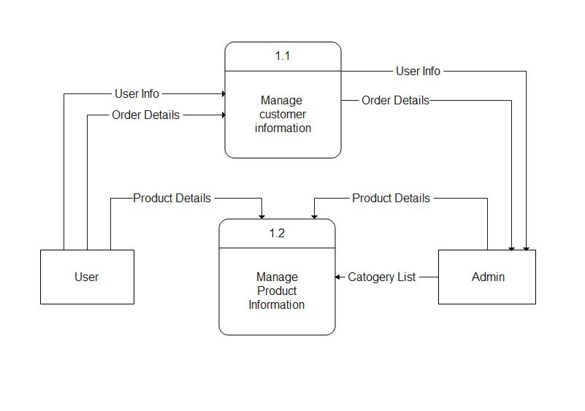

## 

***Fig 3.6.1: DFD Diagram (level 1 DFD) for Ecommerce Website***

## **3.6.3 Data Flow Diagram Level 2**

The Level 2 DFD for E-commerce Website portrays deeper concepts of DFD level 1. It can be used to plan or record all of the specific/necessary information about how the system works.

After presenting the DFD levels 0 and 1, next to that is level 2. The DFD Level 2 was considered as the highest abstraction of E-Commerce Website Data Flow Diagram. This level is expected to have the complete and detailed illustration of the project.

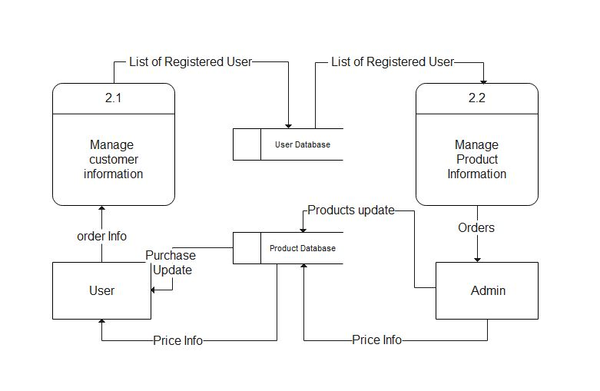DFD Level 2 represents the system’s specified modules as well as the data that flows between them. These modules include the data flow, processes, external entities and the databases. Each of them serves as the guide on how to build the system. As we can see database i.e., user and product give data to 2.1 2.2 Admin and User. User sends Order info and gets Price info and purchase update as well Admin sends price info, Products update and receives Orders.

## 

***Fig 3.6.3: DFD Diagram (level 2 DFD) for Ecommerce Website***

# CHAPTER 4: IMPLEMENTATION AND TESTING

## **4.1. Implementation**

Implementation basically means the phase where the system is actually being built. Firstly, all the information that we gathered is studied and analysed and implemented a system in operation for users. It is one of the most important phases of any project. Implementation usually consists of coding; testing, installation, documentation, training and support. Different tools and technologies that have been used to develop the system which are already discuss in the previous chapter. It is basically converting system design specification into working software.

## **4.1.1. Tools Used**

The various system tools that have been used in developing both the front-end and backend of the project are being discussed in this chapter.

**Front-end**

Bootstrap, HTML, CSS, and JavaScript are used for developing the front-end.

* **HTML (Hyper Text Markup Language):** HTML means Hypertext Markup Language. This language is used in creating web pages. This language also supports other languages such CSS, PHP, JAVASCRIPT, etc. in creating interactive and responsive pages on the pages. HTML is used in this project as front-end and with the help of HTML Registration Page, Login Page, Home Page, Cart Page and Category Page.
* **CSS (Cascading Style Sheets):**CSS is a style sheet language used for describing the look and formatting of a document written in a markup language.CSS is used to define styles for web pages, including the design, layout, and variations in the display for different devices and screen sizes. CSS is used as front-end and with the help of CSS designing text and adding colours in text and Inline CSS is used as managing page design and font.
* **Java script:** Java Script is a dynamic computer programming language. It is most commonly used as part of web browsers, whose implementations allow client-side scripts to interact with the user, control the browser, communicate asynchronously, and alter the document content that is displayed. Java Script is used to create popup windows displaying different alerts in the system like "Added to cart successfully", "Login successful", "Invalid Username/ Invalid Password ".
* **Bootstrap:** It includes HTML and CSS based design templates for typography, forms, buttons, tables, navigation, modals, image etc. It also gives support for JavaScript plugins. design and customize responsive sites with Bootstrap, most popular front-end open-source toolkit, featuring Sass variables. Bootstrap helps to quickly and easily design the webpages.

**Back-end**

The back-end is implemented using PHP and MySQL is used to design the database.

* **PHP:** PHP is used as Back-end in this project. The PHP is used for server-side processing on the web server. PHP is a set of components that provide developers with a framework to implement complex functionality. PHP provides state services that can be utilized to manage session variables across multiple Web servers in a server form. The programming language used in development of project is PHP.
* **MySQL:** MySQL is one of the leading database management systems available on the market today. In this data is stored in the form of tables which can be created and manipulated by using various commands. The database itself has been redesigned to automatically perform many tuning functions, leaving you free to focus on most important tasks.

## **4.1.2. Implementation Details of Modules**

After the design was made and the problems arising from the design process were clarified and dealt with, it was time to start implementing the application. Implementing application of this scale requires lots of resources and explaining the whole implantation process will not be clarified in this paper. However major important aspects in the implementation will be described. Some modules of the shopping websites are listed below:

* Header: It displays the header with the logo of the shopping website, social media or the login. It is used in the navbar of the homepage. It is used in order to provide links to different pages of the website.
* Breadcrumbs: It is used to automatically display the path taken to get to the page.
* Register Form: It is used in order to register the new users to the website. It contains the text field like email, username and password. The information entered is further stored to be used in the login page.
* Login Form: It is used in order to provide the user the gateway to the website. It uses the data like username and password from register form to authenticate the user and give further access.
* Shopping Cart: It displays the quantity of products and the prices of the products which is to be bought by the user.
* Product Modules: Since the shopping website offers two different Shopping categories, Product modules divides different products according to their categories. Users can select the products according io their choices.
* User Module: It provides information related to the user. It Provides information like cart detail, product detail, login, register and logout.
* Admin Module: It provides information to the admin. It provides information like user detail, Admin can add or remove products etc.

## **4.2 Testing**

Testing is done to check the behaviour of a complete and fully integrated software product based on the software requirement specification document. For the application or website to be deployed it has to be tested. Hence test cases will be written to test this application. They are many types of tests to be carried out on a web application from performance, functionality, database loading time, response time, server time handling, user's actions and many others. We will not carry out all types of tests for the application considering the time scale to present this project Hence performance check related to upload time, memory usage will be part of a future test. We will focus the test cases on functionality, security and performance. So that various types of testing procedures were performed in order to check the working mechanism and correctness of the system. Some of the types of testing that we did are described below:

1. Verify that all the specified fields are present on the registration page.

2. Verify that clicking submits button after entering all the required fields, submits the data to the server.

3. Verify that not filling the optional fields and clicking the submit button will still send data to the server without any validation error.

4. Check validation on the phone no and email fields (only valid phone no and valid email Ids should be allowed).

5. Check validation on numeric fields by entering alphabets and special characters.

6. Verify cart value after entering negative values and 0.

## **4.2.2. Test Case for System Testing**

## **Register page test case**

|  |  |  |  |  |  |
| --- | --- | --- | --- | --- | --- |
|  | Test Case Description | Test Data | Expected  Result | Actual Result | Pass/  Fail |
| A_LOG_1 | Admin  enters an invalid email | username: 1324gmail.com  password: 1234 | Display message **The email format is invalid. | As expected, | Pass |
| A_LOG_2 | Admin enters a wrong password | email:1234@gmail.com password:1234 | Display message ** Password mismatch** | expected | Pass |
| A _LOG_3 | Admin  enters valid email and password | email:milankarki723@gmail.com  password- user123 | Logged into  Login page | As  expected, | Pass |

## 

## **Login page Test case**

|  |  |  |  |  |  |
| --- | --- | --- | --- | --- | --- |
|  | Test Case  Description | Test Data | Expected ResuIt | Actual Result | Pass,'Fai |
| A LOG | Admin enters a wrong email | email: 1324gmail.com password: 1234 | Display message **The email is not found* * | expected | Pass |
| A_LOG_2 | Admin enters a wrong password | email: 1234@gmail.eom password: 1234 | Display message **Password does not match ** | As expected | Pass |
| A_LOG_3 | Admin enters valid email and | email: milankarki723@gmail.eom password: user123 | log into  Home page | As expected | Pass |

## 

## **Shopping cart Test case**

|  |  |  |  |  |
| --- | --- | --- | --- | --- |
| ID | Test case  Description | Expected Result | Actual Result | Pass,'FaiI |
| A_LOG_ | Adds Negative Value in cart. | The cart will not add the value less than 1 | As expected | Pass |
| A_LOG_2 | Add products in cart. | Product added | As expected | Pass |
| A_LOG_3 | Remove and update product in cart. | Product updated and removed successfully | As expected | Pass |

# CHAPTER5: CONCLUSION AND FUTURE RECOMMENDATION

## 

## **5.1. Outcome**

When this project is completed, the users will be able to buy various products. After filling the register form, user can view and buy different products online through web browser. User can easily add and remove products from the cart.

## 

## **5.2. Conclusion**

The electronic shop was developed using PHP, MySQL, HTML and CSS technology. Any consumer can browse products, add, replace or delete a product from the cart. The consumer can log in, with his information such as his email and password. If the login does not go through, the user can re-register. After login, the user can see the product in the cart and proceed onwards. The administrator can verify the order. However, the consumer can still look at the orders in his or her account. The ordered is saved in the database

Choosing PHP for this project is because it is very simple and easy to use, it could handle a lot of data and easily manipulation compared to another scripting language, this is widely used all over the world. it is Open source; we can freely download and use. And it is platform independent as well.

As complementing the end of the project, we realized that there are many enhancements that can be made on the application. Some of these ideas came from those who tested the application following the specification because they were realistic to achieve in this given amount of time. Any other enhancements to the application can be done in future development of the application.

## 

## 

## **5.3. Future Recommendation**

Here is what can be added in the future on this website to increase its usability, user experience and portability of the website. There is a lot to be done hence this application can be considered as a starting point for something big to come. It will need more time and resources for all these to be done but it is still very realistic and possible to achieve.

* Addition of transaction methods
* Access the applications on a small device (mobile app),
* Addition of new shopping categories.
* Making project device compatible.
* Advance Shopping Cart.

# REFERENCES

|  |  |
| --- | --- |
| [1] | techtarget.com,“techtarget.com,”.[Online].Available:https://www.techtarget.com/searchcio/definition/e-commerce. [Accessed 2022 3 3]. |
| [2] | erdplus.com, erdplus.com,”erdplus.com, [Online].Available:https://erdplus.com/standalone. [Accessed 4 3 2022]. |
| [3] | .researchgate.net.”researchgate.net”,[Online].Available:https://www.researchgate.net/publication.[Accessed 5 3 2022]. |
| [4] | Ramesh singh saudh , Software Engineering, Ktm: KEC Publication, 2020(Revised). |

# 

# APPENDICES

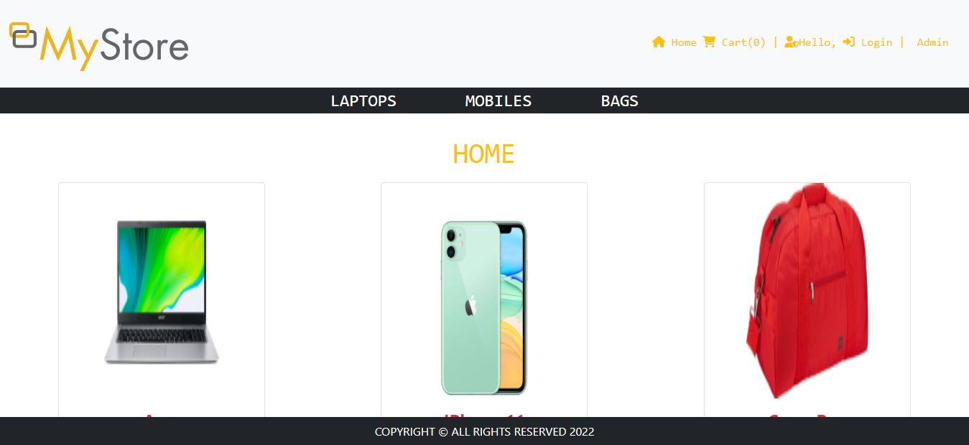

***Fig: Home Page***



***Fig: Admin Login***

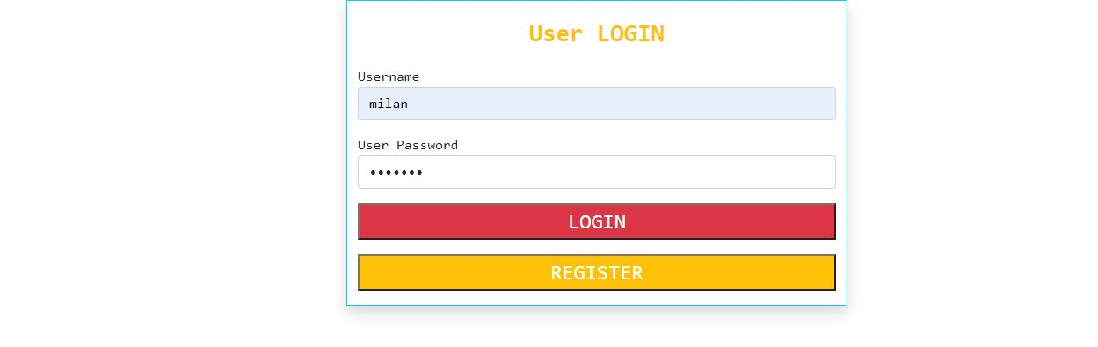

***Fig: User Login***

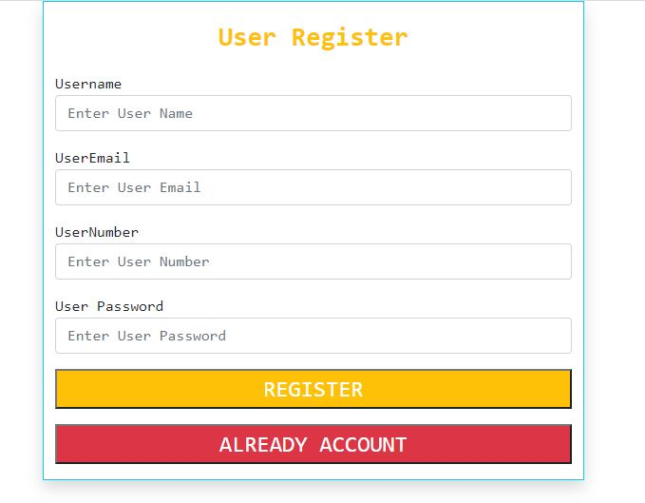

***Fig: User Register Page***

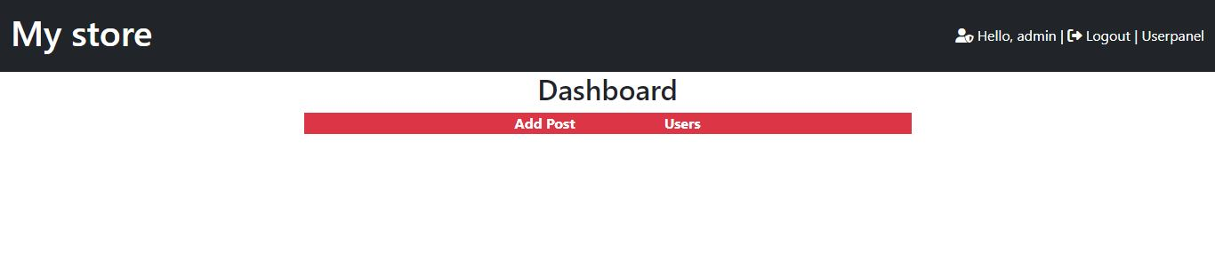

***Fig: Admin Home Page***

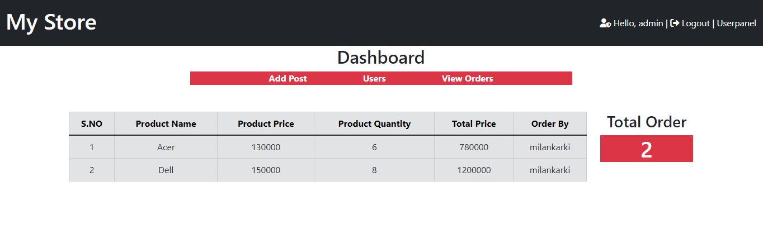

***Fig: Admin View Order Page***

**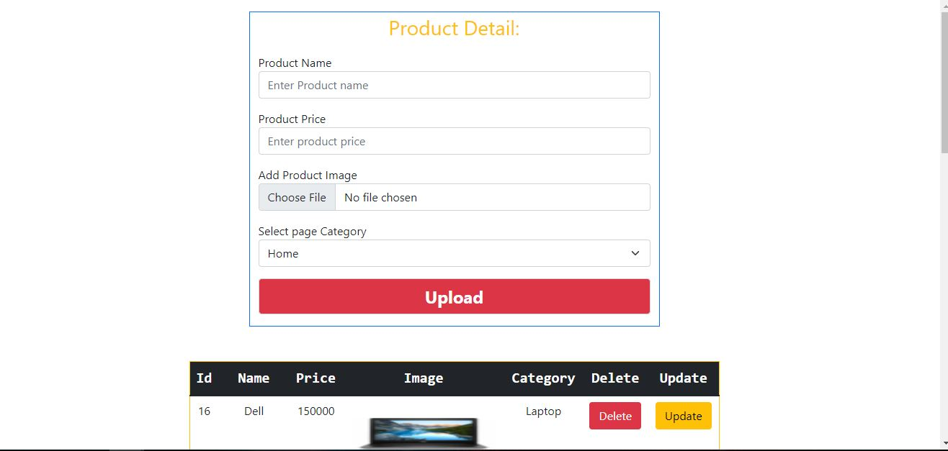*Fig: Admin Insert Page***

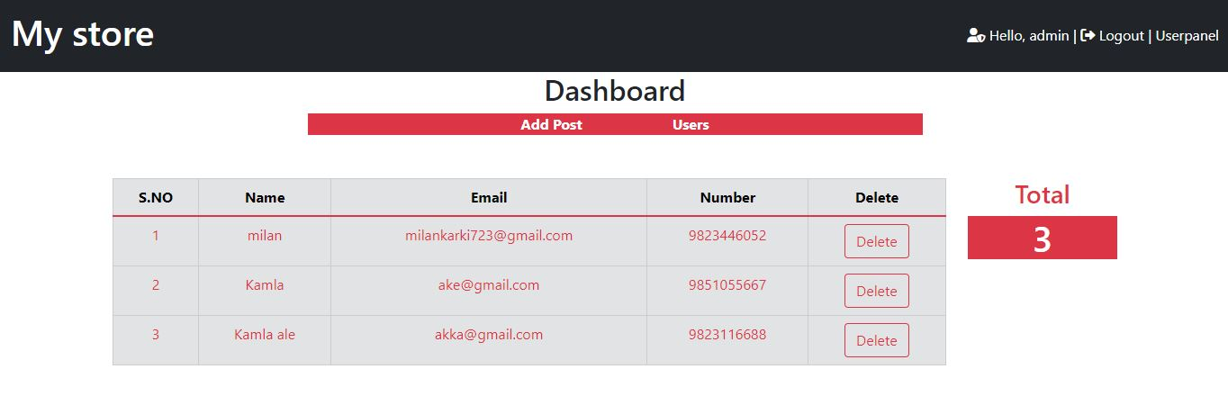

***Fig: Admin Manage User Page***

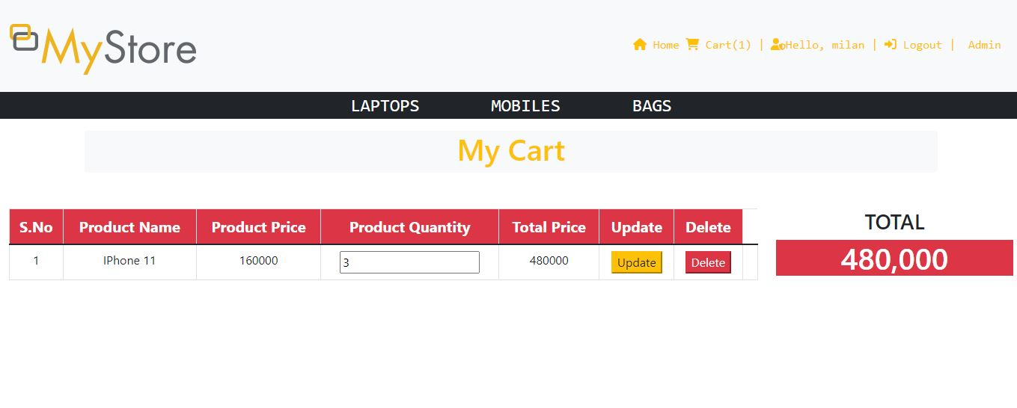

***Fig: Cart Page***

**Category Page:**

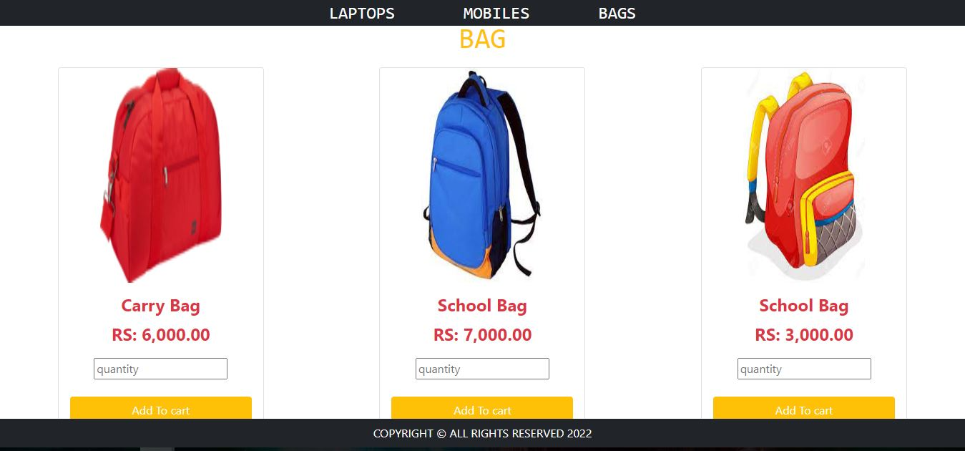

***Fig: Bag Page***

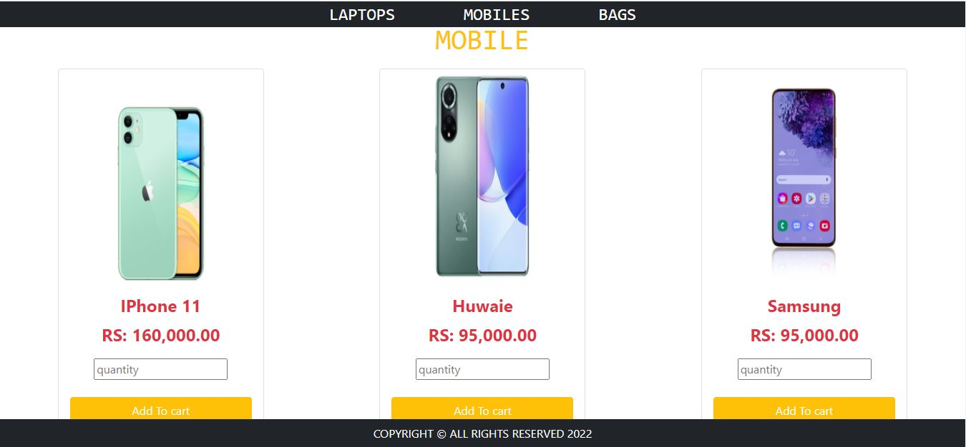

***Fig: Mobile Page***

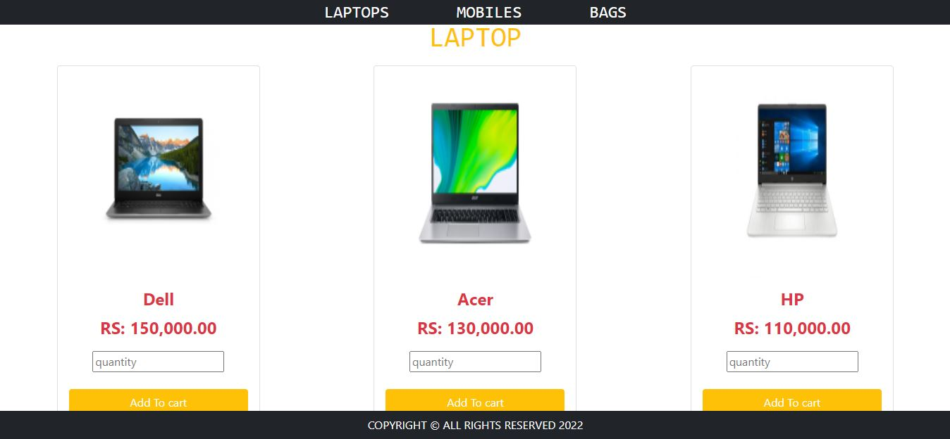

***Fig: Laptop Page***